**Environment Setup Document**

Student was able to download, install and setup the majority of the required software and environments in the program. The following document details how each application/technology was installed and the steps taken to complete this:

1. Windows 11 migration

* Windows 11 was successfully downloaded on to the student’s machine
* Windows 11 could not be installed due to system requirements not being met for the upgrade
* Alternatively, the student installed the latest Windows 10 22H2 to mitigate this problem.

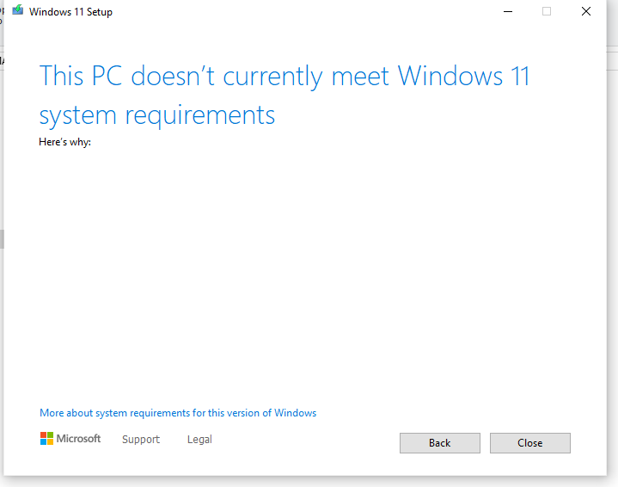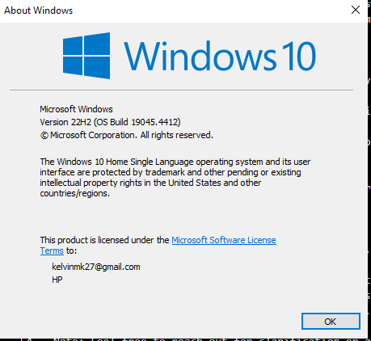

1. IDE/Text Editor setup
   * Student downloaded Microsoft Visual Studio Code from Google Chrome and installed the application.
   * Microsoft Visual Studio Code was successfully installed on the machine and student can now utilize the application.
   * Alternatively, the machine has the following text editors that can be uses as code editors: Text Document, Notepad++ and Emacs

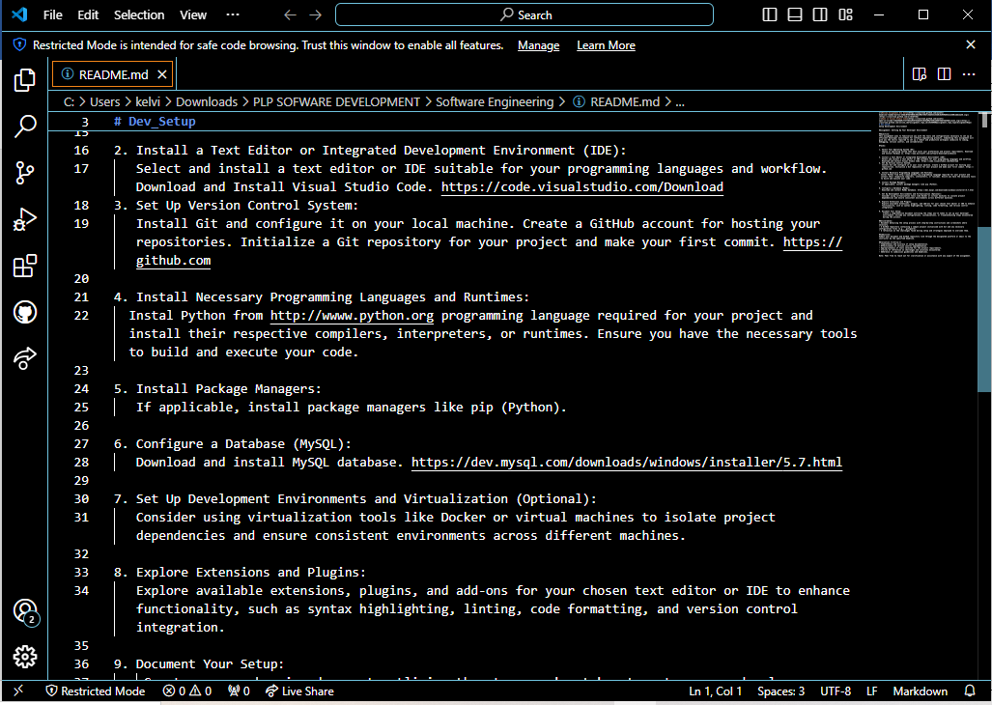

1. Version Control Installation
   * Student chose to download and install Git for version control
   * Git was successfully installed and linked to a remote Github account
   * git init was use to initialize the current working repository

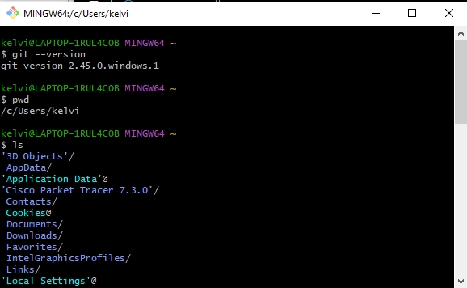

1. Programming languages runtime
   * Student downloaded the latest version of Python
   * Python was successfully installed to the machine and can be detected
   * Student also downloaded Dart
   * Dart bin file path was added to the system environment variables
   * 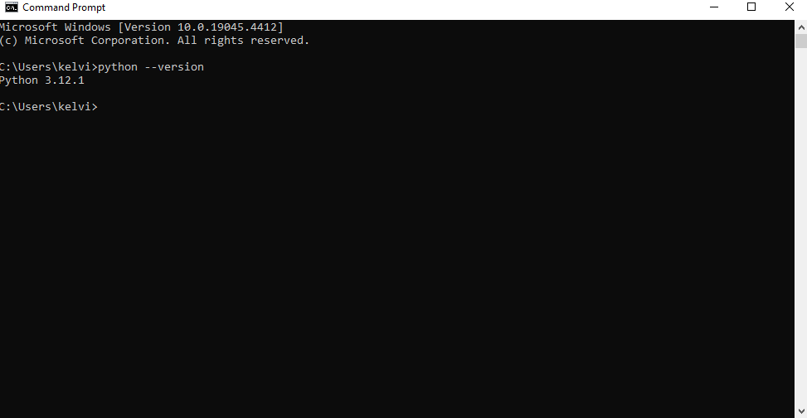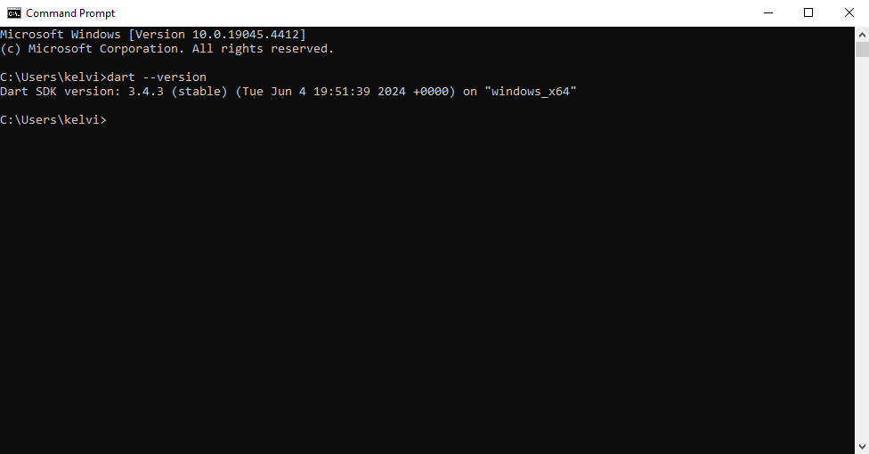Language was successfully installed on the machine
2. Install package manager
   * Chocolatey was chosen for windows package manager
   * The following commands were used:

Set-ExecutionPolicy Bypass -Scope Process -Force

[System.Net.ServicePointManager]::SecurityProtocol = [System.Net.ServicePointManager]::SecurityProtocol -bor 3072; iex ((New-Object System.Net.WebClient).DownloadString('https://community.chocolatey.org/install.ps1'))

* + The commands threw an error and student was not able to troubleshoot

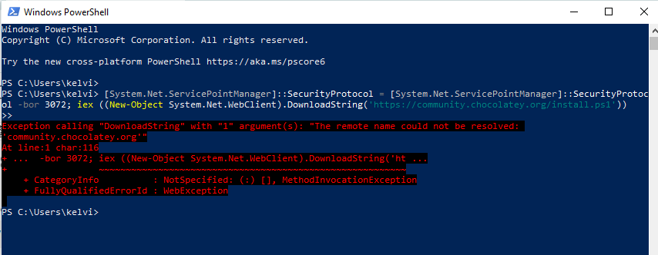

1. MySQL Install
   * Student was able to successfully download MySQL
   * MySQL was instaled and setup was done
   * Student connected MySQL to a local host server
2. IDE Extensions
   * The following language’s extensions were installed on Microsoft Visual Studio Code: Python, Dart
   * The live server extension was also installed to run code in real-time